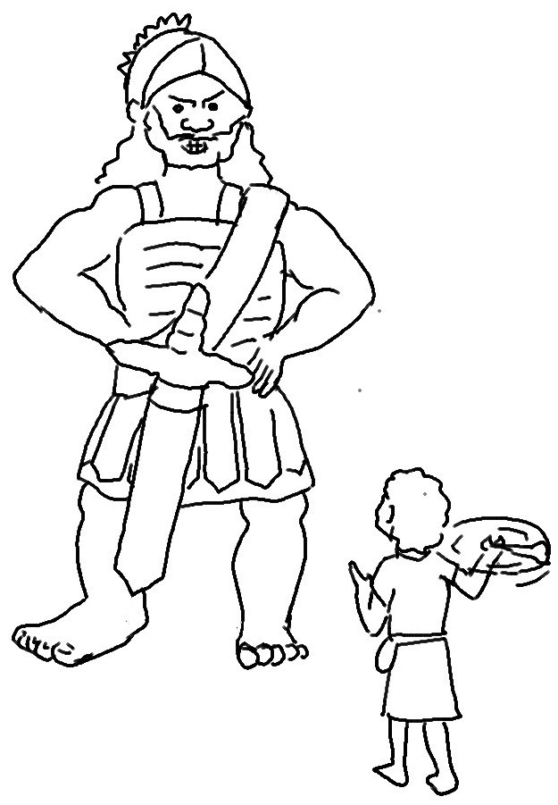
"You come to me with sword, spear, and javelin, but I come to you in the name of the Lord…"
1 Samuel 17:45_{NLT}

